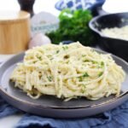
Boursin Pasta
4 Servings
Ingredients
8 oz Pasta
2 Tablespoons Butter
2 cloves Garlic minced
¾ cup Heavy Whipping Cream
4 oz Package Boursin Herb and Garlic Flavor
Salt and Pepper to taste
Directions
- Prepare the pasta according to package directions.
- While the pasta is cooking, start preparing your sauce.
- In a skillet over medium heat, melt the butter.
- Once the butter is hot, add the garlic and cook for 2 minutes until lightly golden.
- Whisk in the heavy whipping cream and cook until thickened, about 4 minutes.
- Cut up the Boursin cheese and add to the skillet, stirring frequently.
- Once the cheese is melted and fully incorporated into the cream sauce, season to taste with salt and pepper.
- Add the drained pasta to the skillet and toss to coat completely.

